**PGPDSE FT Capstone Project –Final Report**

**Dry Eye Disease Prediction**

**Industry Review:**

* **Industry Review – Current practices, Background Research** 
  + This data from diverse subjects with age ranging from 18 to 45, enabling researchers and healthcare professionals to explore correlations between lifestyle factors and ocular health.
  + The dataset can be used for machine learning models, statistical analysis, and clinical decision-making to enhance early detection and personalized treatment strategies for DED.
* **Literature Survey - Publications, Application, past and undergoing research**
  + Data is actually got from Kaggle.
  + Person who uploaded the data is Daksh Nagra.
  + The data can also be used to predict another severe sleep related diseases such as insomnia which can be directly linked with ocular surface diseases (OSD).

**Dataset and Domain:**

**1. Data Dictionary**

In this data we have a total of **26 columns** and the dictionary or overview of the data is a below.

Output:

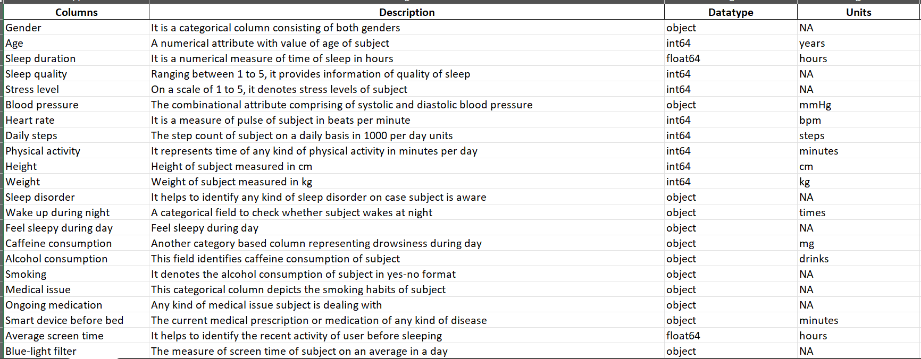 

1. **Variable categorization (count of numeric and categorical)**

There are totally 10 numerical columns and 16 categorical columns

Output:

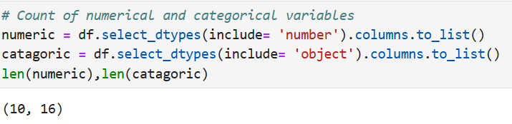

1. **Pre Processing Data Analysis or checking the defects (count of missing/ null values, redundant columns, etc.**
2. **Duplicates in Data**

There are no Duplicates or duplicate values in data

Output:

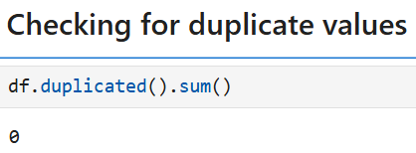

1. **Missing values**

There are no missing values in data

Output:

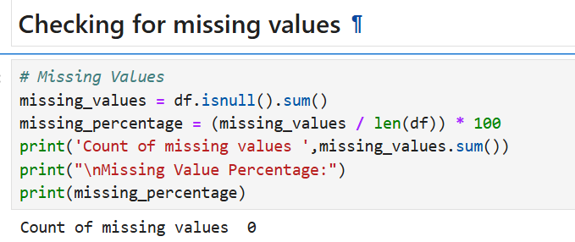

1. **Statistical Summary**

For numerical columns

The statistical summary for **11 numerical** are is also known **as 5-point summary.** Below we have the inferences from descriptive analysis

Output:

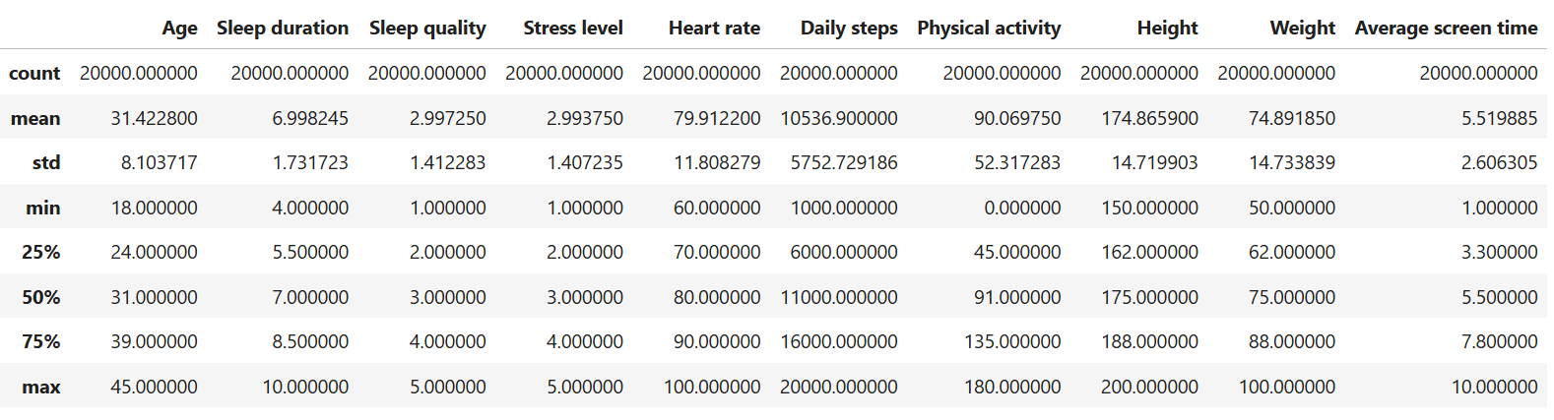

Inferences:

1. **Age**: This is a relatively young to middle-aged population. The narrow age range may affect generalizability to older adults or children.
2. **Sleep duration**: On average, participants meet recommended sleep duration (7–9 hours). However, a significant portion sleeps below that threshold (min = 4), which may affect health and screen-time related disorders.
3. **Sleep quality:** Normal distribution centered at moderate sleep quality. There’s noticeable variance, suggesting some individuals experience poor sleep regularly.
4. **Stress level**: stress levels average around medium, with enough spread to detect differences among individuals. This could be a critical feature when analyzing lifestyle-related conditions.
5. **Heart rate**: All within normal resting heart rate range.
6. **Daily steps:** Quite active on average — the general guideline is 10,000 steps/day. High variance suggests significant lifestyle differences (sedentary vs. active users).
7. **Physical activity**: On average, people meet the recommended 30 mins/day. But some are completely inactive (0 minutes) — a possible risk factor for lifestyle diseases.
8. **Height:** Represents a fairly typical adult height distribution.
9. **Weight:** Standard weight range for adults.
10. **Average Screen Time**: High screen time on average — this may correlate strongly with eye strain, dry eye disease (DED), and sleep quality issues. A key feature

For Categoric columns:

The statistical analysis for 18 categoric columns is 4 points summary – count, unique, top, freq,

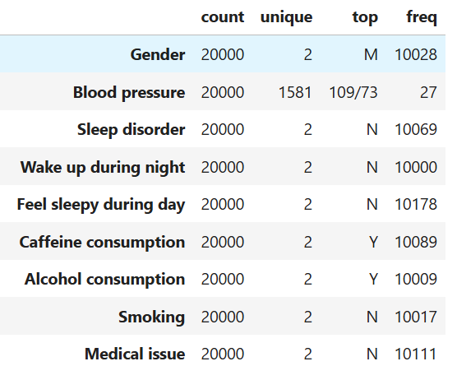

Mostly, all columns are having unique values but **blood pressure** looks like having anomaly issue.

1. **Outliers**

From plotting all the boxplot graphs for the numerical columns, we can conclude there is no outliers present in the data.

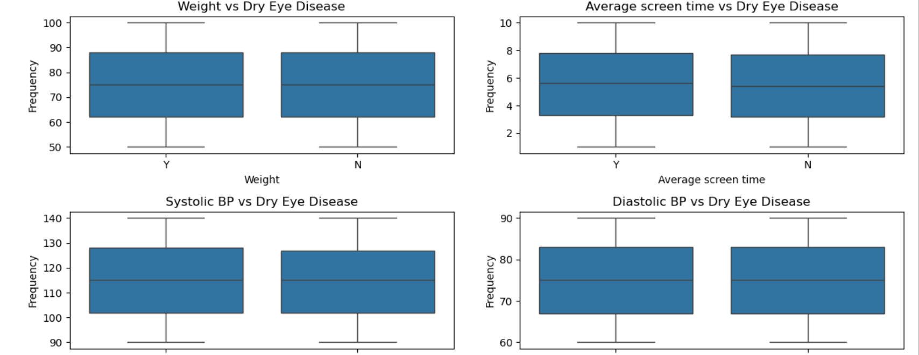

* No serve outliers in most features
* Distributions appear fairly normal or slightly skewed in some cases.

1. **Defects in Data**

We have to check for the anomalies present in the data.

From the descriptive analysis of categorical data, we can observe that **blood**

**pressure** has anomaly issue.

1. **Alternate sources of data that can supplement the core dataset (at least 2-3 columns) (Feature Engineering)**

We are not having any additional source of data but created few columns from the existing data -

1. For **Systolic BP** and **Diastolic BP** –

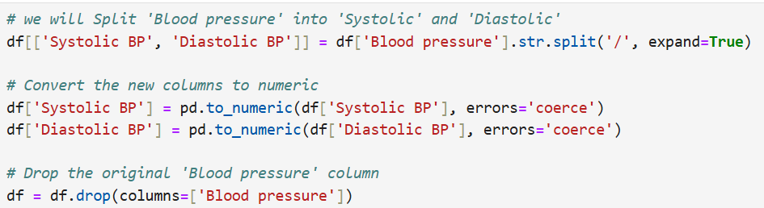

Also, we have classified three more columns from the existing data.

1. **BP_category** – This is done using from Systolic BP and Diastolic BP is done based on American Heart Association

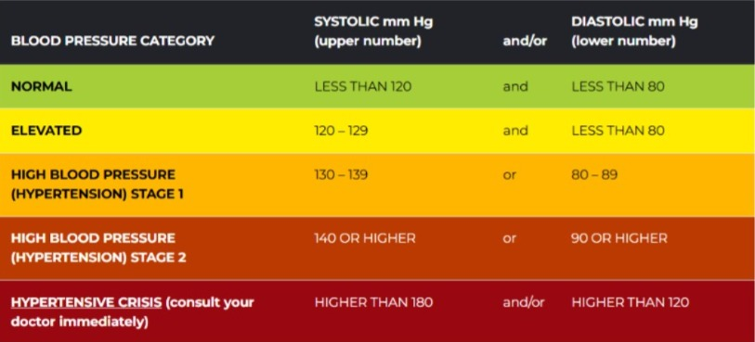

1. **Sleep_Category** – This is done using Sleep duration column is done on basis data from WHO.

According to National Heart Lung and Blood Institute of America, Experts recommend that Adult should have sleep at least 7-9 hours of sleep every day.

1. **Screen Time Category** – This is done using Average Screen Time column on the basis of National Health institute
2. **BMI**: This column is found using the columns Height and Weight.
3. **Pusle Pressure**: This is done by the difference between Systolic and Diastolic BPs
4. **Project Justification - Project Statement, Complexity involved, Project Outcome –**

**Project Justification:**

1. **Project Statement:**

This dataset is used for prediction of dry diseases on key attributes like sleep quality, sleep duration, eye redness, itchiness, screen time, blue-light filter usage and eye strain for the people under the age category of 18-45 in a given population.

1. **Project Outcome:**

We classify people who are having the problem of Dry Eye Disease so that they can get their eyes treated at the earliest.

1. **Complexity Involved:**

The Complexity issues which we face are –

* Class imbalance
* Skewed distribution
* Anomalies
* Outliers

1. **Commercial, Academic or Social value**

The **Social value** in this problem we are helping people **to improve their eyesight level** and have health lifestyle as without proper vision as they may face problems in day-to-day life.

**Data Exploration (EDA)**

1. **Relationship between variables**

We have found the correlation between all variables present in the data.

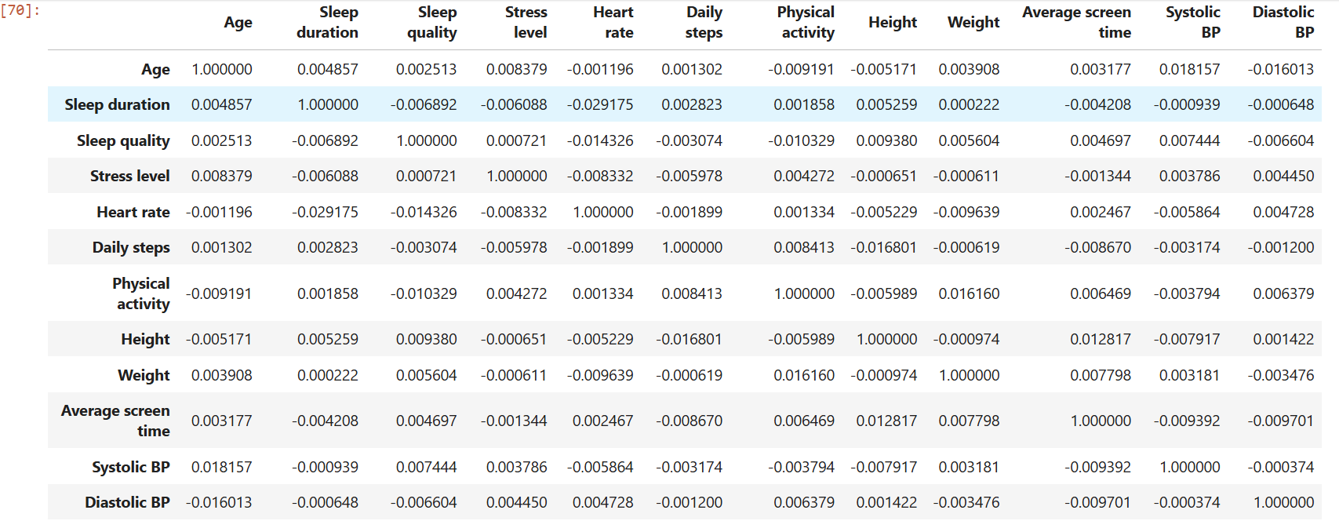

From the above code we can see that,

1. Age has a **weak positive** correlation with Sleep duration, Sleep quality, Stress level, Weight, Average screen time, Daily steps, and Systolic BP, and a **weak negative** correlation with Heart Rate, Physical Activity, Diastolic BP, and Height.
2. Sleep duration has a **weak positive** correlation with Daily steps and Physical activity, and a **weak negative** correlation with Sleep quality, Stress level, Heart rate, Average screen time, Systolic BP, and Diastolic BP.
3. Sleep quality has a **weak positive** correlation with Stress level, Systolic BP, and a **weak negative** correlation with Sleep duration, Heart rate, Daily steps, and Physical activity.
4. Sleep level has a **weak positive** correlation with Sleep quality, Heart rate, and Diastolic BP, and a **weak negative** correlation with Sleep duration, Daily steps, Physical activity, Height, and Weight.
5. Heart Rate has a **weak positive** correlation with Stress level and Diastolic BP, and a **weak negative** correlation with Age, Sleep duration, Sleep quality, Daily steps, Physical activity, Height, and Weight.
6. Daily Steps has a **weak positive** correlation with Sleep duration and Physical activity, and a **negative** correlation with Age, Sleep quality, Stress level, Heart rate, Height, Weight, and Average screen time.
7. Physical Activity has a **weak positive** correlation with Sleep duration and Daily steps, and a **weak negative** correlation with Age, Sleep quality, Stress level, Heart rate, Height, and Average screen time.
8. Height has a **weak positive** correlation with Average Screen Time, and a **weak negative** correlation with Age, Sleep duration, Stress level, Heart rate, Daily steps, and Physical activity.
9. Weight has a **weak positive** correlation with Age and Average screen time, and a **weak negative** correlation with Stress level, Heart rate, Daily steps, and Height.
10. Average Screen Time has a **positive correlation** with Age, Height, and Weight, and a **negative correlation** with Sleep duration and Daily steps.
11. Systolic BP has a **weak positive** correlation with Sleep Quality, and a **weak negative** correlation with Sleep duration, Height, and Average screen time.
12. Diastolic BP has a **weak positive** correlation with Stress level and Heart rate, and a **weak negative** correlation with Sleep duration and Average screen time.
13. **Check for** 
    1. **Multi-collinearity:**

Below is the diagram for multicollinearity:

Output:

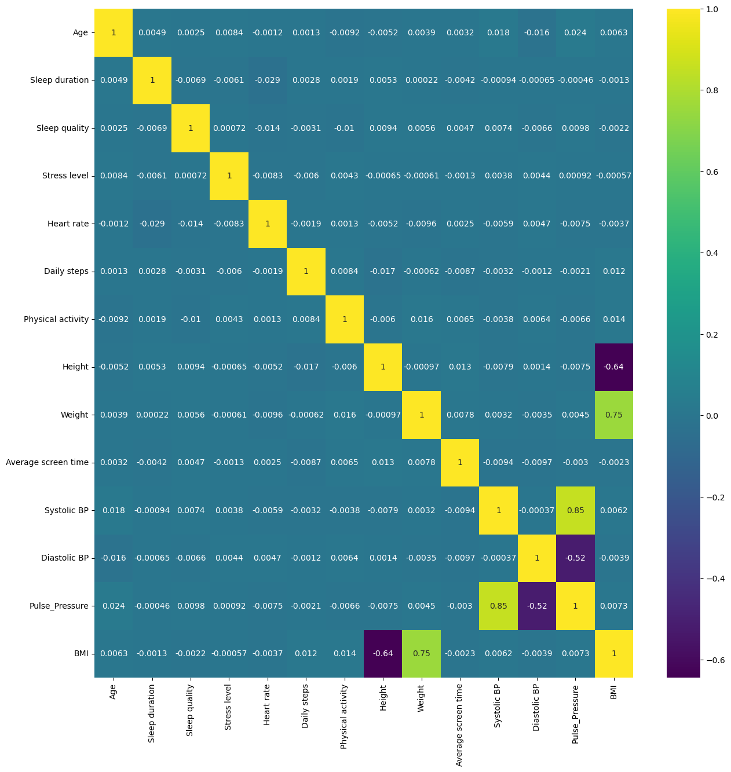

From the above output we can observe that,

Columns – Height, Weight, Systolic_BP, Diastolic_BP , Pulse Pressure, BMI are having **multicollinearity** issues**.** Also,

1. Systolic BP shows a **strong positive** correlation with Pulse Pressure (0.85), meaning higher systolic pressure is associated with higher pulse pressure.
2. BMI has a **strong positive** correlation with Weight (0.75) and a strong negative correlation with Height (-0.64), which is expected given BMI's formula.
3. Diastolic BP is **moderately negatively** correlated with Pulse Pressure (-0.52), indicating an inverse relationship.
4. Most features like age, sleep duration, physical activity, screen time, etc., show very **weak or negligible** correlations with each other (values close to 0), suggesting they are largely independent in this dataset.
   1. **Distribution of variables**

We have done analysis of the distribution of the variables in both univariant and bivariant methods.

**Univariant Analysis:**

Output:

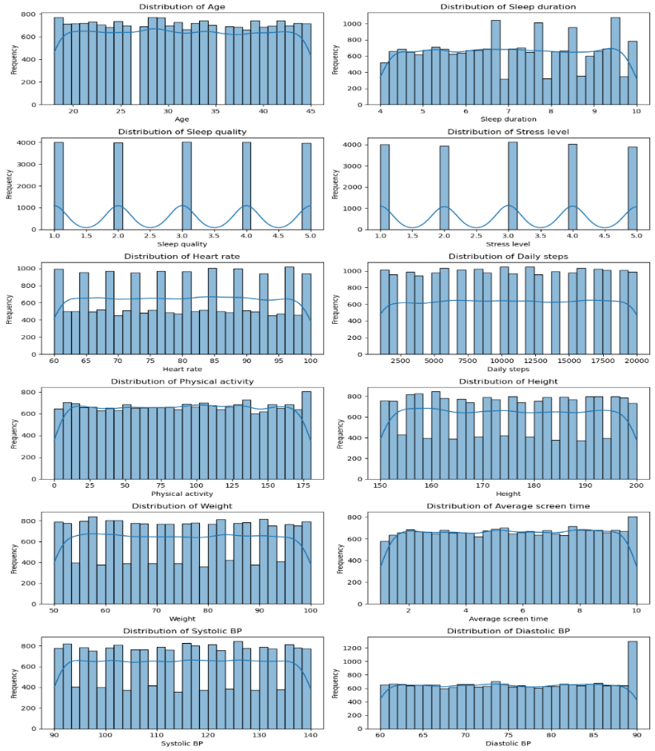

Inference:

* 1. **Age**: The age distribution appears roughly uniform between 18 and 45, but there's a notable absence of older adults (above 45 years).
  2. **Sleep duration**: Sleep Duration is slightly right-skewed — many sleep around 6–8 hours, which is ideal, but a subset sleeps <6 hours.
  3. **Sleep quality**: Sleep Quality shows an even spread — indicating variability, and low sleep quality is a known DED risk factor.
  4. **Stress level**: Stress Level: Spread across the full 1–5 scale. Some users report high stress.
  5. **Average Screen Time**: Nearly uniform, with many individuals having >6 hours/day of screen time. High screen exposure reduces blink rate, a direct trigger for Dry Eye Disease — this is likely a strong predictive feature.
  6. **Heart rate**: Uniform, but some individuals are on the higher side (90–100 bpm).

Categorical:

Output:

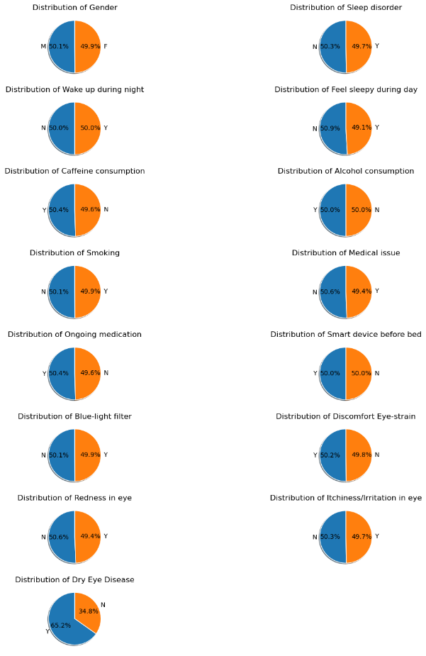

Inference:

* **Dry Eye Disease**: Yes: 65.2%, No: 34.8%
* Indicates a mild class imbalance — might influence classification metrics like accuracy.

**Bivariant Analysis:**

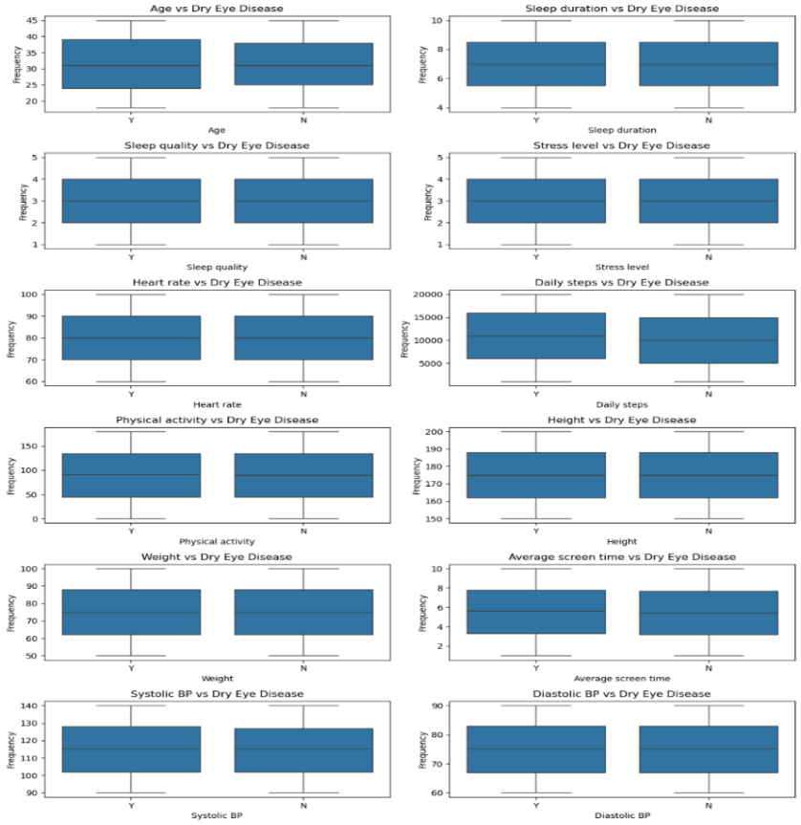

Inference:

1. **Age**: Slight upward trend in DED frequency with increasing age. Indicates that older individuals are more prone to Dry Eye Disease.
2. **Sleep Duration**: Moderate fluctuations, but overall, DED frequency seems slightly lower with longer sleep durations. Poor sleep may be linked to increased risk of DED.
3. **Heart Rate**: No strong pattern observed, though slightly more DED cases are seen at lower and higher extremes, suggesting possible impact of health/stress levels.
4. **Daily Steps**: Slight downward trend – more physically active individuals (higher steps) seem to have fewer DED cases. Physical activity may help reduce risk.
5. **Physical Activity**: High variability, but generally lower DED frequency at moderate-to-high activity levels. Reinforces that inactivity might correlate with DED.
6. **Height**: No consistent relationship with DED observed. Likely not a significant predictor.
7. **Weight**: Slight upward trend in DED frequency with increasing weight.
8. **Average Screen Time**: Clear upward trend: more screen time strongly correlates with higher DED frequency. Indicates screen exposure is a major risk factor.
9. **Systolic BP**: Moderate rise in DED frequency at higher systolic BP. High BP might be indirectly linked to DED via overall health conditions.
10. **Diastolic BP**: Similar trend to systolic – DED increases with higher diastolic BP. Suggests possible vascular or systemic health impact on eye health.

Categorical:

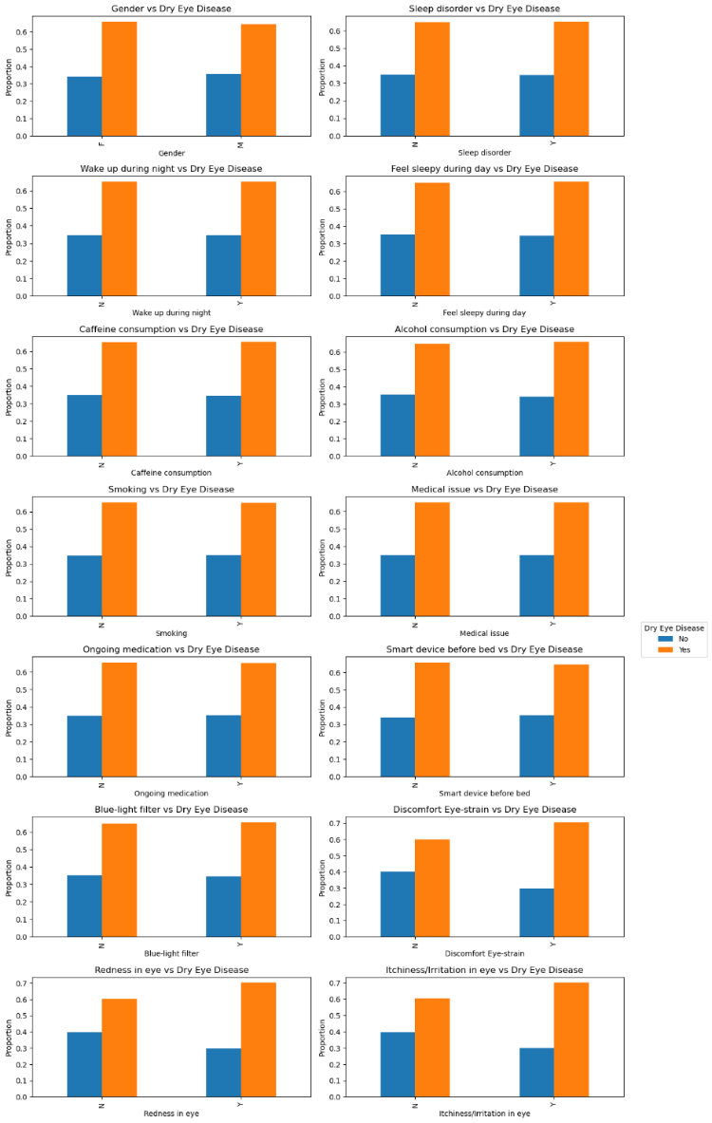

Inference:

* 1. **Females**, individuals with **poor sleep quality, high stress, and sleep disorders** are more likely to have **Dry Eye Disease (DED).**
  2. Excessive **screen time**, especially before bed, and symptoms like **eye strain, redness, and irritation** are strong indicators of **DED**.
  3. Use of **blue-light filters** and maintaining good sleep hygiene may help reduce the risk of **DED**.
  4. Health factors such as **medical issues, ongoing medication, and smoking** also show moderate influence on **DED** presence.

**Mutli variant Analysis:**

1. We can have plotted a pair plot to show the combination of each variables over the other columns and plotted it.

**Output:**

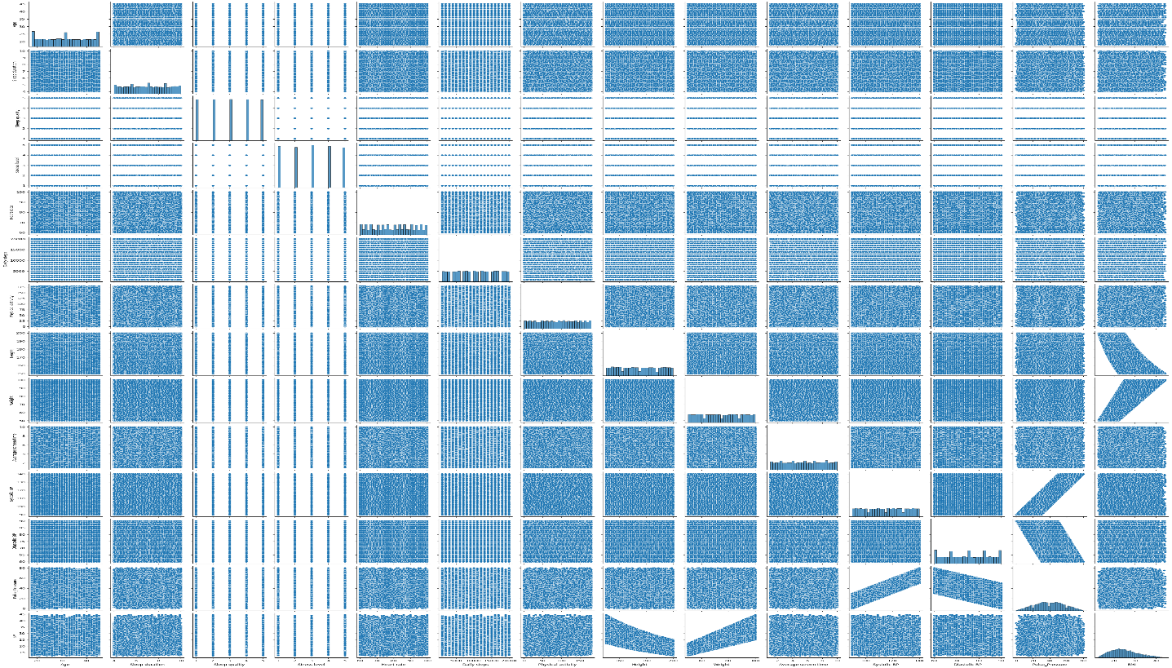

* 1. **Statistical significance of variables or Relationship between variables.**

We have check how all the independent variables (all column expect Dry Eye Disease) are statistically significant with the target variable (Dry Disease Eye column)

For Numerical variables:

Code:

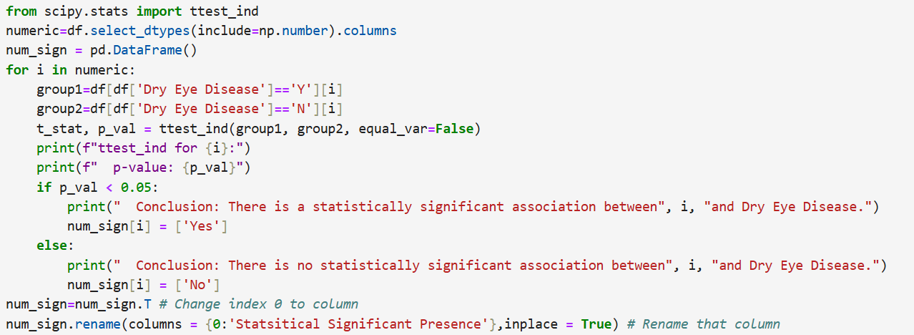

Output:

| **Independent Variables** | **Statistically Significant/ Relation with Target Column** |
| --- | --- |
| **Age** | No |
| **Sleep duration** | No |
| **Sleep quality** | No |
| **Stress level** | No |
| **Heart rate** | No |
| **Daily steps** | No |
| **Physical activity** | No |
| **Height** | No |
| **Weight** | No |
| **Average screen time** | Yes |
| **Systolic BP** | No |
| **Diastolic BP** | No |
| **Pulse_Pressure** | No |
| **BMI** | No |

For Categorical variables:

Code:

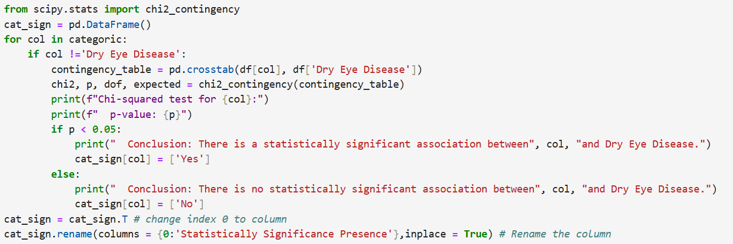

Output:

| **Independent Variables** | **Statistically Significance/ Relation with Target column** |
| --- | --- |
| **Gender** | Yes |
| **Sleep disorder** | No |
| **Wake up during night** | No |
| **Feel sleepy during day** | No |
| **Caffeine consumption** | No |
| **Alcohol consumption** | No |
| **Smoking** | No |
| **Medical issue** | No |
| **Ongoing medication** | No |
| **Smart device before bed** | No |
| **Blue-light filter** | No |
| **Discomfort Eye-strain** | Yes |
| **Redness in eye** | Yes |
| **Itchiness/Irritation in eye** | Yes |

* 1. **Class imbalance and its treatment**

For the target column: Since the values is having Yes class as 65% and No for 35 %. This target seems to be having no imbalance of data of data. So no balancing is done.

**Pre Processing for Model**

1. **Transformations requirement**

No Transformation is applied on any column as the distribution seems to be normal.

1. **Scaling the data**

Since few columns like the 'Age', 'Sleep_duration', 'Sleep_quality', 'Stress_level', 'Heart_rate','Daily_steps', 'Physical_activity','Average_screen_time', 'Systolic_BP', 'Diastolic_BP', 'Pulse_Pressure','BMI’ are containing larger values and many columns are having different units so, we used Standard Scaling method in this model. (consider all these columns as numcol)

Output:

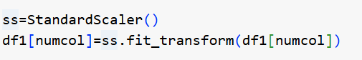

1. **Encoding:**

We have used dumpy encoding and map function for encoding all the categorical values

**Output:**

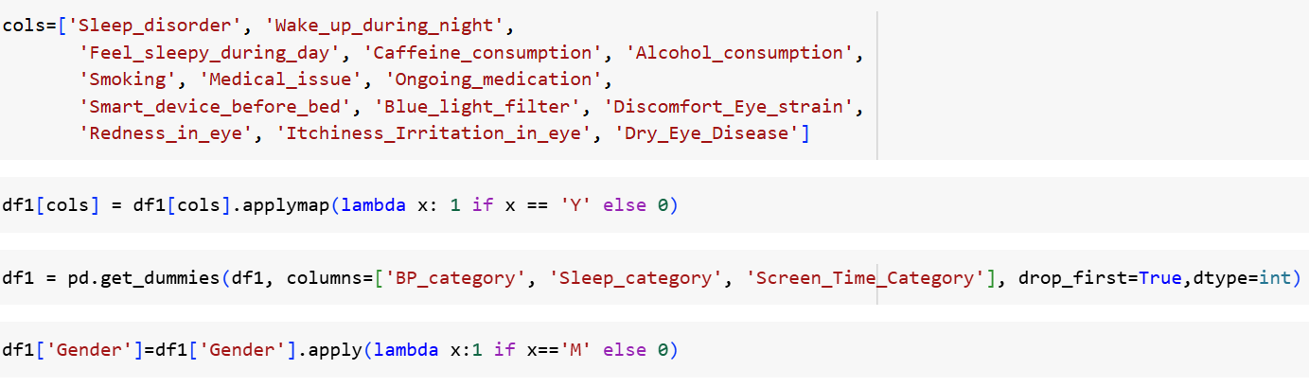

**Modelling:**

**Assumptions**

Check for the assumptions to be satisfied for each of the models in

1. **Assumptions for the use of SLR or Linear Regression** is the target should be a numerical column and must satisfy all these below conditions for it be Linear Regression model

Assumptions –

1. Target column should be numeric
2. There should be a linear relationship between target and independent variables
3. Must not have multicollinearity
4. Absence of Autocorrelation
5. Errors should be homoscedastic
6. Errors must follow normal distribution

**But our model the target is categorical so Linear Regression is ruled out. Only Classification Models are used.**

1. **Assumptions for Classification model**:

For Classification model if the target is categoric then we can apply.

Here Since the target Dry Eye Disease is categorical, we apply all the Classification model – Logistic Regression, Decision Tree, Random Forest, AdaBoost , Gradient Boost, XGBoost etc.

Also, we will perform hyper parameter tunning for the models other than Logistic Regression if any overfitting / underfitting issue is present.

**Analyzing Underfit and Overfitting issues.**

After running all models, we have arrived at analyzing all models’ accuracy of both train and test data to find whether any of the model is performing under fit or over fit.

**Train model:**

|  | **Model Name** | **Accuracy Score** | **Precision Score** | **Recall Score** | **F1 Score** |
| --- | --- | --- | --- | --- | --- |
| **0** | **Base model for Logistic Regression** | **0.683357** | **0.681519** | **0.965374** | **0.798984** |
| **0** | **Decision Tree Model (Base)** | **0.624286** | **0.645548** | **0.924859** | **0.760364** |
| **0** | **Random Forest** | **1.000000** | **1.000000** | **1.000000** | **1.000000** |
| **0** | **ADA Boosting Model (Base)** | **0.680571** | **0.678457** | **0.958772** | **0.794617** |
| **0** | **GB Model base** | **0.697357** | **0.696534** | **0.939931** | **0.800132** |
| **0** | **XG model** | **0.913929** | **0.895408** | **0.981048** | **0.936274** |
| **0** | **SVM model base** | **0.707857** | **0.697021** | **0.967084** | **0.810138** |
| **0** | **LGBM Base model** | **0.729571** | **0.719839** | **0.950238** | **0.819146** |

Test Model:

|  | **Model Name** | **Accuracy Score** | **Precision Score** | **Recall Score** | **F1 Score** |
| --- | --- | --- | --- | --- | --- |
| **0** | Base model for Logistic Regression | 0.677167 | 0.677966 | 0.961391 | 0.795178 |
| **0** | Decision Tree Model (Base) | 0.568500 | 0.689243 | 0.646487 | 0.667181 |
| **0** | Random Forest | 0.700333 | 0.709373 | 0.935227 | 0.806791 |
| **0** | AdaBoosting (Base) | 0.686000 | 0.693355 | 0.951420 | 0.802142 |
| **0** | GB Model base | 0.703333 | 0.712035 | 0.934479 | 0.808231 |
| **0** | XG model | 0.654333 | 0.701999 | 0.839811 | 0.764746 |
| **0** | SVM model | 0.693500 | 0.699285 | 0.950673 | 0.805828 |
| **0** | LGBM base model | 0.698833 | 0.710311 | 0.928500 | 0.804881 |

From the above table we observe the all of the models are facing much of overfitting issues ( few models face heavily but rest faced little overfitting issue.

**Models:**

1. **Logistic** **Regression**-

Firstly, we have created a base model for train data and test data with Logistic Regression algorithm. Let’s check the metrics of the model –

**Confusion Matrix:**

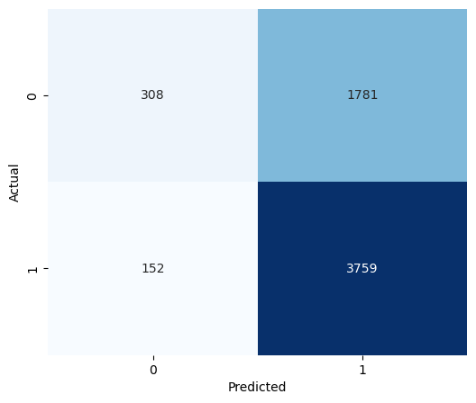

The model looks to perform well and predicts all values perfectly.

**Classification Report:**

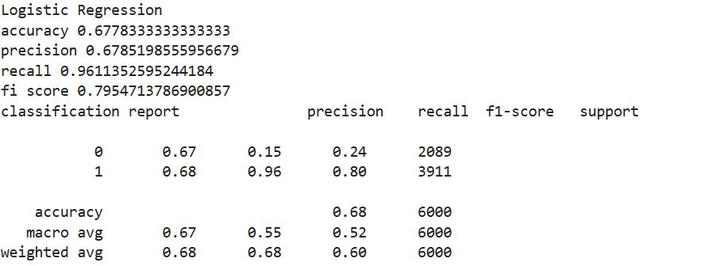

Here the accuracy from model is 68%. The model predicts values perfectly as positives since recall value is higher compared to precision value for a person who is suffering from DED.

Looks, there may be a problem of multicollinearity in the model. Checking the multicollinearity issue in model.

We have applied VIF on the X_train data and found 6 columns facing multicollinearity,

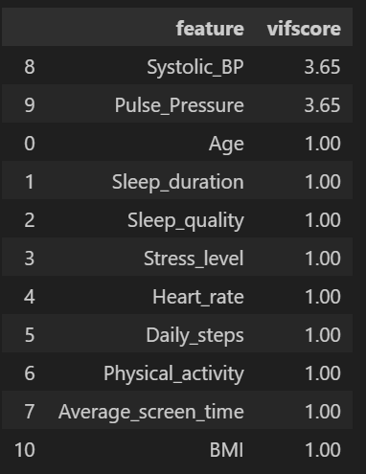

Now we need not remove few columns and perform again. Checking again the metrics,

**Confusion matrix:**

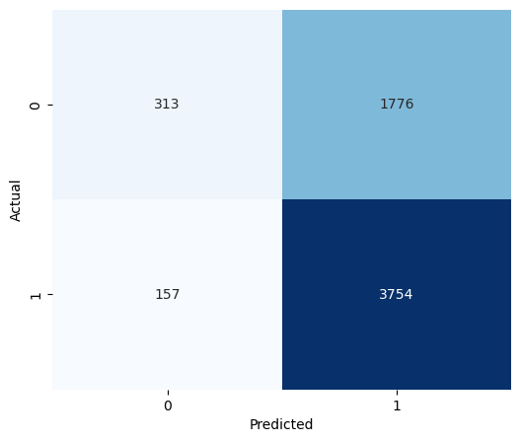

**Classification Report:**

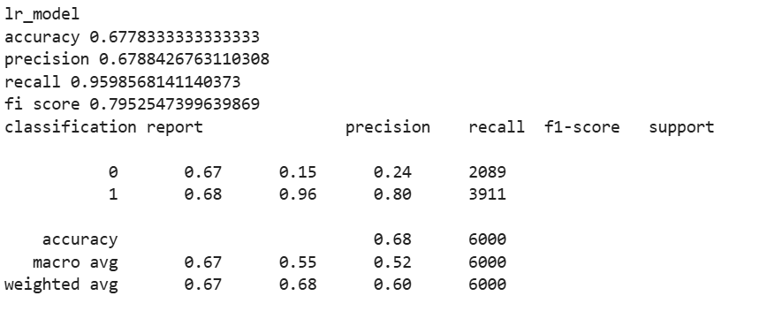

We get the same accuracy rate.

1. **Decision Tree modelling –**

Let’s, first create a base Decision Tree model using X and y data. Let’s see the metrics of the model

**Confusion Matrix:**

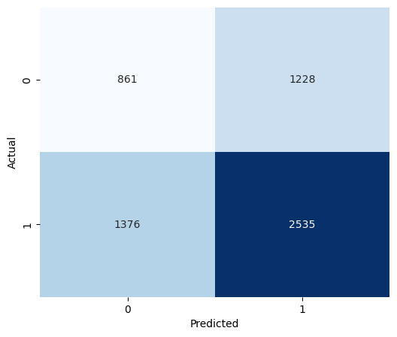

From the matrix we can observe that model is predicting the positive values more than negative class values.

**Classification Report:**

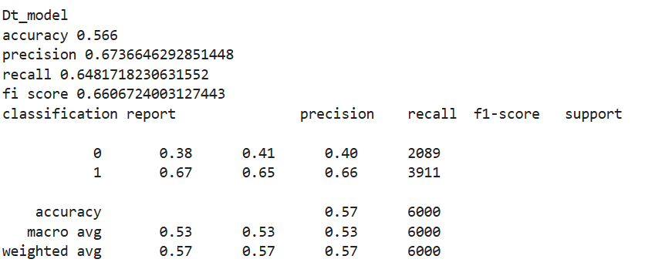

Since the **accuracy** of the model is still only at **57%**. For the person having disease precision is **69%** and recall is **65%** which shows the poor model generalization or overfitting issue. So, let’s use hyper parameter tunning to improve the performance of precision and recall of the model.

Tunned parameters:

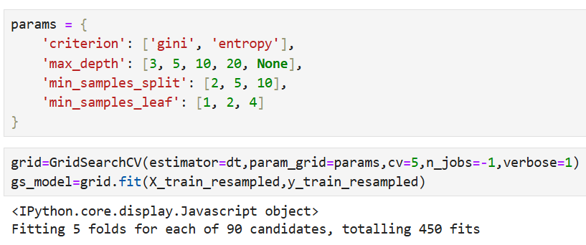

From this the above parameters the best parameters found using GridSearchCV are:

1. **Criterion:** Entropy
2. **Max_depth:** 5
3. **Min_samples_leaf:** 4
4. **Min_samples_split:** 2

After finding the best fit parameters we run the model again and check the metrics,

**Confusion Matrix:**

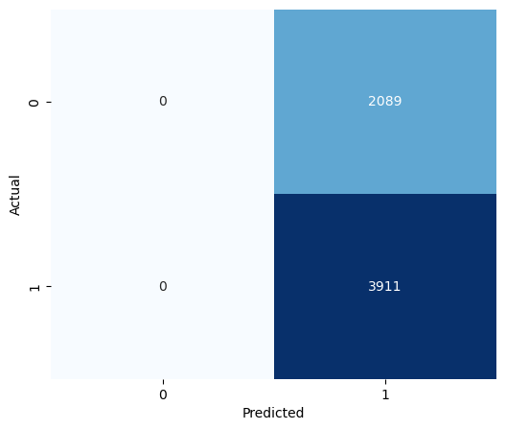

**Classification Report:**

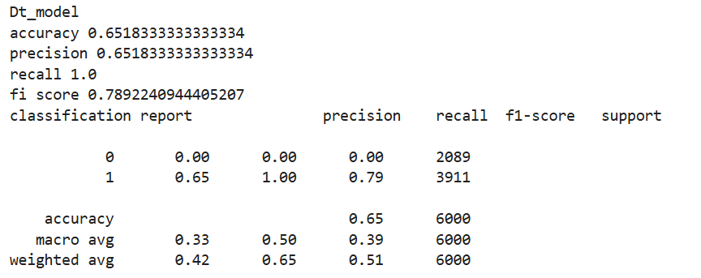

Now after tunning, accuracy of the model is improved to 65%, the precision and recall values are also improved and are predicting more of positive values to 70% and 86% for person having dry eye disease.

**Important Features of the model are:** Itchiness/Irritation in Eye, Redness in Eye, Discomfort in Eye Strain, Average Screen time, BMI, Pulse Pressure, Systolic BP, Physical Activity, Daily Steps, Sleep duration, Gender, Heart Rate.

1. **Random Forest modelling –**

We perform Random Forest Algorithm and create a base model for X and y data. Let’s see the metrics of the Model.

**Confusion Matrix:**

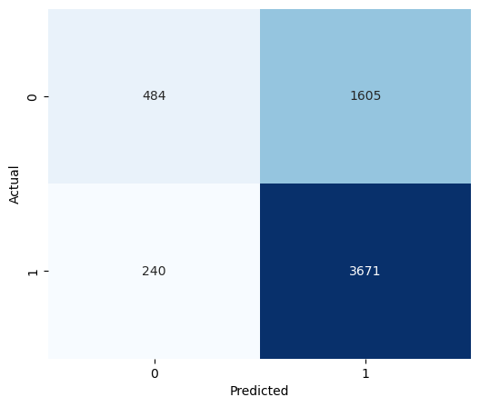

**From this we can observe that the model is predicting more true values more perfectly which is a positive sign of the model performance.**

**Classification Report:**

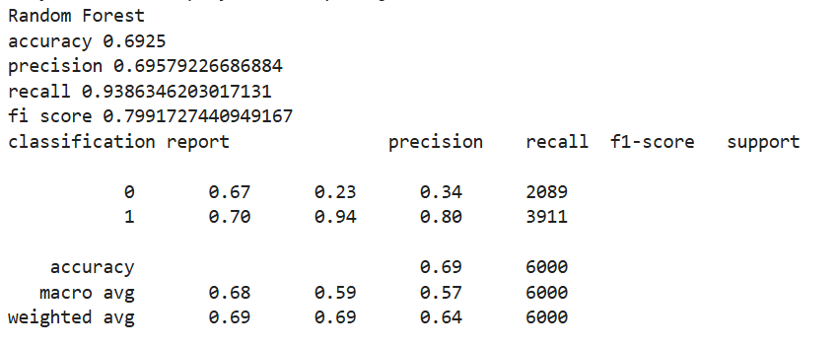

**From this model Accuracy score is around 69% and for person suffering from dry eye diseases the prediction value of recall is better than precision is also higher. (indicates all positive values are predicted). Let’s perform parameter tunning to improve the accuracy score.**

Tunning Parameters:

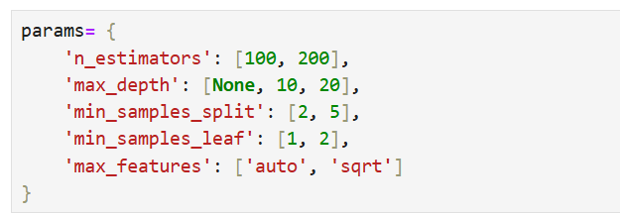

**The best parameters are found by running GridSearchCV are:**

**N_estimators:** 200

**Max_depth:** None

**Min_samples_split:** 5

**Min_samples_leaf:** 2

**Max_features:** None

Now running the model again and checking the metrics again are,

**Confusion Matrix:**

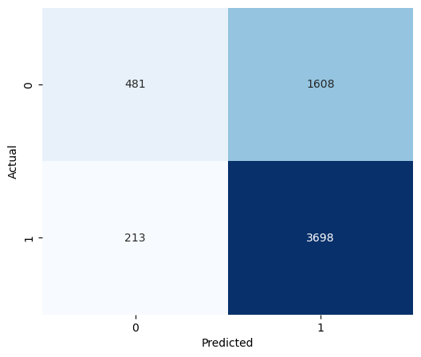

**Classification Report:**

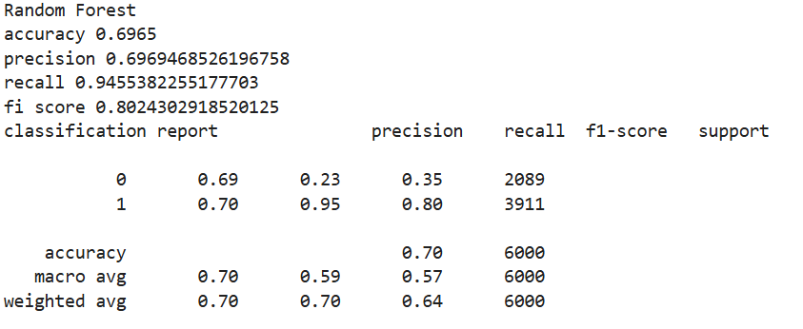

**We can now see the model accuracy is again decreased to 68 and also recall value of class 1 is remains almost same.**

**Important Features of the model are:** All the features look important. But the top few features which shows more impact in with Target Dry Eye Disease is BMI, Physical Activity, Average Screen Time, Pulse Pressure, Sleep duration, Heart Rate, Systolic BP, Age, Daily Steps.

1. **AdaBoosting modelling –**

Let’s create AdaBoosting base model using X and y data. Let’s see the metrics:

**Confusion Matrix:**

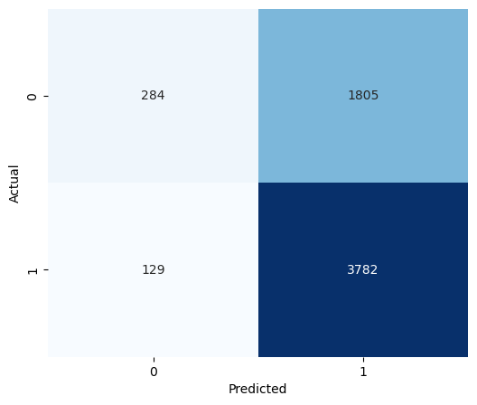

**Classification Report:**

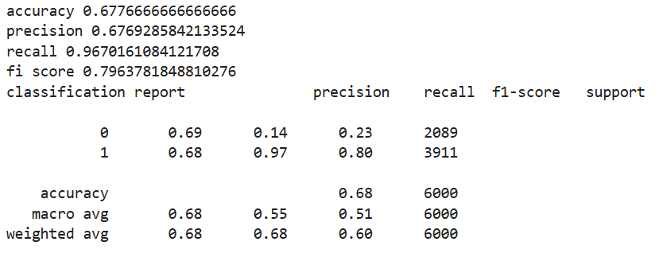

**Accuracy score of the base model is 68 % and also recall is good than the precision value for person having dry eye disease (predicts more of positive values. So, let’s try parameter tunning to improve the accuracy and other parameters.**

Tunned parameters:

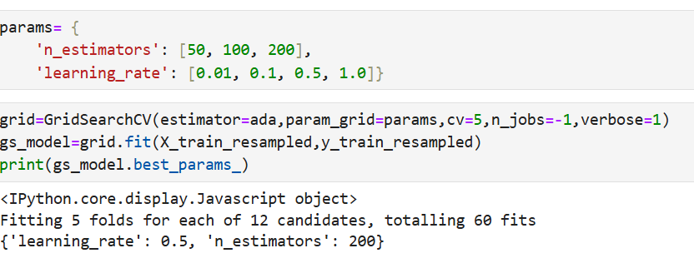

**Best parameters are using GridSearchCV are:**

**Learning_rate:** 0.5

**N_estimators:** 200

Once again build the model and check the metrics.

**Confusion Matrix:**

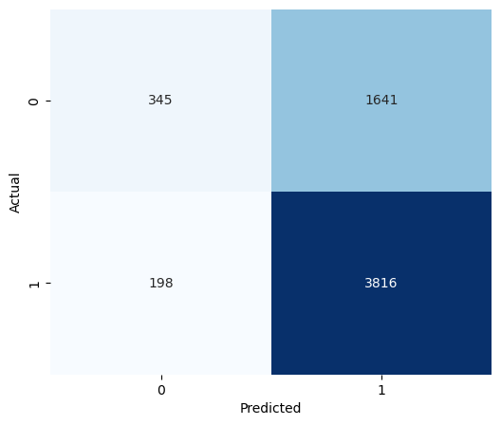

We can see the model is predicting more for postive values.

**Classification Report:**

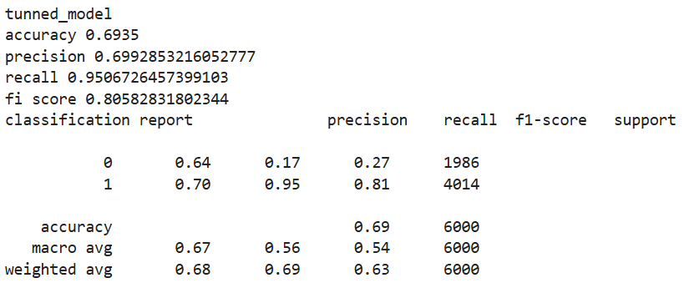

Now, the accuracy is 69%, precision is less than recall values show the model is having more positive value predictions in the model.

**Important Features for this model:** Discomfort Eye Strain is more having impact of Dry Eye in this model.

1. **Gradient Boosting Model-**

Creating a base model with Gradient Boosting Algorithm using X and y data. Let’s check the metrics of the model.

**Confusion Matrix:**

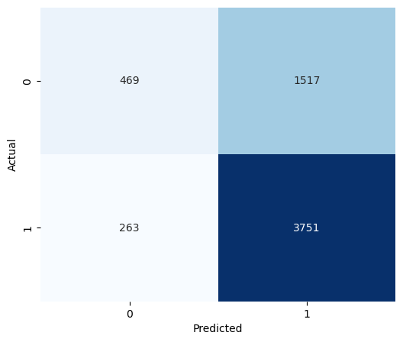

The predictions looks good with more of prediction on positive values.

**Classification model:**

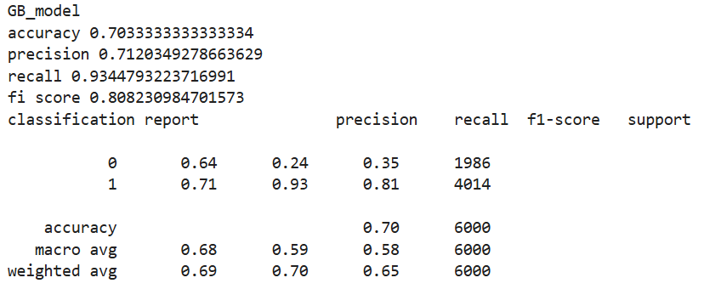

**The model has accuracy of 70% with predicting for person having dry eye disease is better and good for this model. Now let’s try parameter tunning for accuracy improvement.**

**Tunning the model:**

Below are the parameters for tunning:

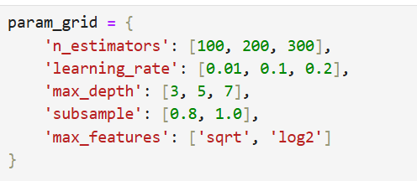

Best parameters are:

**Learning_rate**: 0.1

**Max_depth:** 5

**Max_features:** sqrt

**Min_samples_split**: 2

**Min_samples_leaf:** 3

**N_estimators:** 100

**Subsample**: 1.0

Now run the model again with these parameters and check the metrics again,

**Confusion Matrix:**

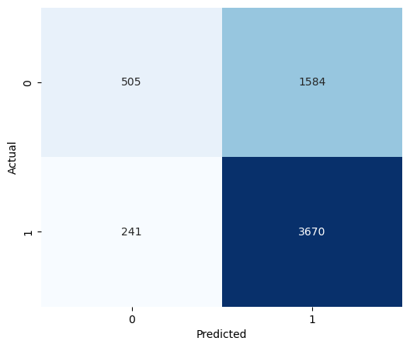

**Classification Report:**

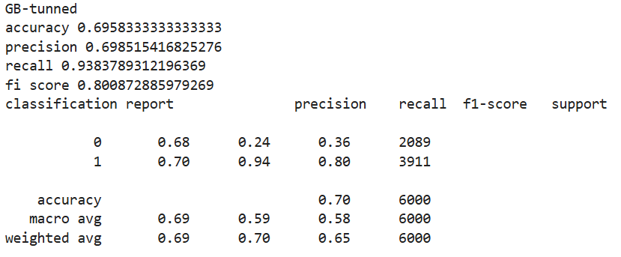

**Now again the accuracy is same and the recall and precision values is also reduced.**

**Important Features for this model are:**  Almost all the Features seems to be need but in that the top most few features are Irritation/Itchiness in Eye, Redness in Eye, Discomfort in Eye Strain, BMI, Physical Activity, Pulse Pressure, Average Screen Time, Sleep duration and Heart Rate.

1. **XGBoosting Model –**

Create a base model with XG boosting algorithm using X and y data. The metrics of the model are:

Confusion Matrix:

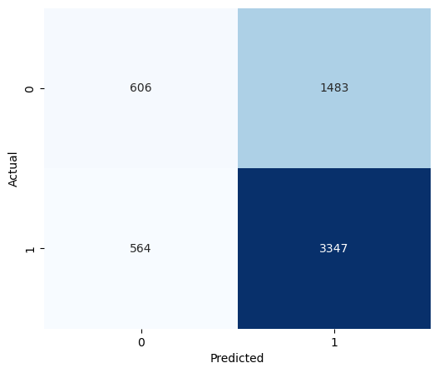

**Classification Report:**

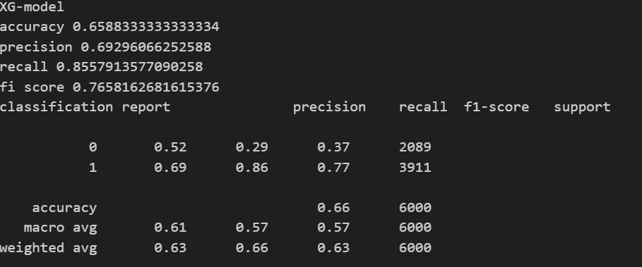

**Accuracy score for the model is 70% and this comparative good than the random forest model. Also, the recall value is higher so let’s perform some tunning of parameters.**

**Let’s tune the model:**

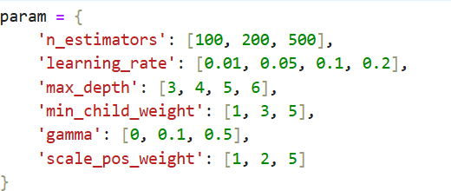

**Best parameter values are:**

**N_estimators:** 100

**Learning-rate:** 0.01

**Max_depth:** 3

**Min_child_weight:** 1

**Gamma:** 0

**Scale_pos_weight:** 2

Let’s run the model again using these parameters. The results of metrics of new model are:

**Classification Report:**

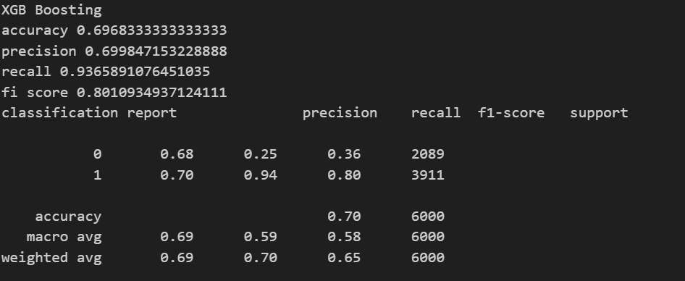

The Accuracy is 70% and precision is 70% for only class1 and 0 for precision 0 for class 0 which is not good predictions.

**Important Features for this model are:** Itchiness/Irritation in Eye, Redness in Eye Discomfort Eye Strain, Systolic BP, Daily steps, Average screen time, Alcohol Consumption, Sleep quality, Pulse Pressure, Sleep duration, Heart Rate and BMI.

1. **LightBGM Model:**

Create a base model using X and y data for the model. The metrics are:

**Classification Report:**

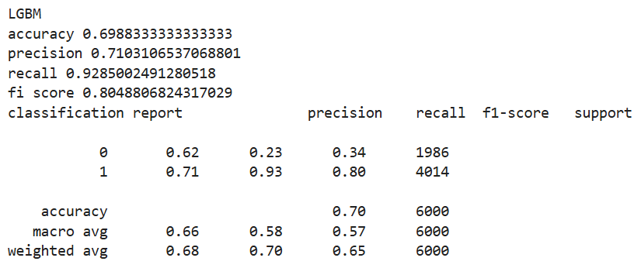

The Accuracy of the model is about 70%. Precision value is greater than recall which indicates the model is predicting more to positive class values.

Let’s tune the model and run build it again.

Tunned Parameters:

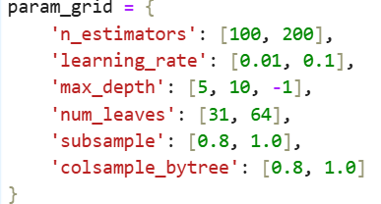

**Best Parameters are:**

**N_estimators: 200**

**Learning_rate: 0.01**

**Max_depth: 5**

**Num_leaves: 31**

**Subsample: 0.8**

**Colsample_bytress: 1**

**Now new model metrics are:**

**Confusion Matrix:**

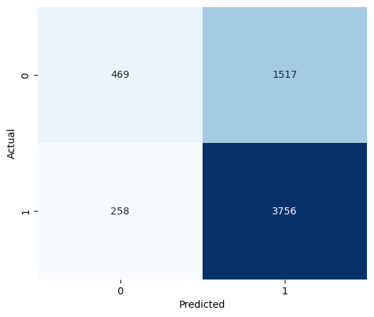

**Model predicts more of Positive class values.**

**Classification Report:**

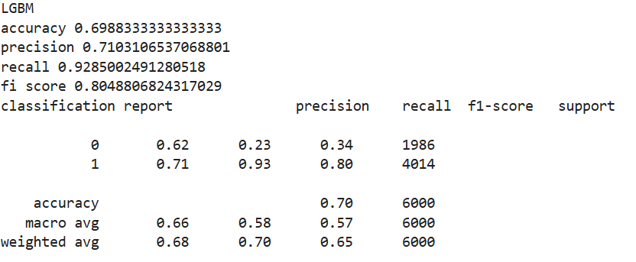

**The Accuracy of the model is 70%. Also, precision value is lesser compared to recall which shows that we have models predicting on positive class values more.**

**Important Features are:** Pulse Pressure, Average Screen Time, Physical Activity, BMI, Sleep duration, Systolic BP, Heart Rate, Age, Daily steps, Itchiness/Irritation in Eye, Redness in Eye, Discomfort in Eye Strain, Stress level and etc. have impact on target.

1. **SVM Model:**

Create a base model using X and y data the metrices for the model are:

**Confusion Matrix:**



This model is predicting more of positive values which is good sign.

**Classification Report:**

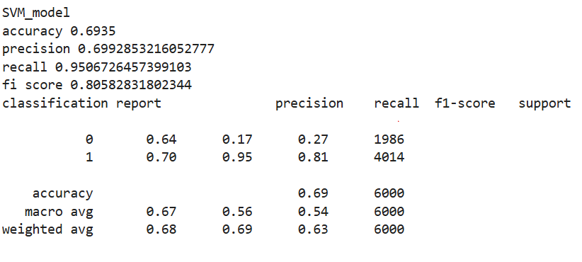

The Accuracy is around 69% with precision of 70% and recall of 90% for the class 1 which tells that more of positive values is predicated**.**

**Tunned Params:**

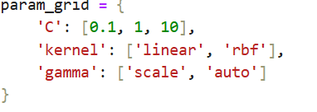

**The best tunned parameters are:**

**C: 1**

**Kernel: rbf**

**Gamma: scale**

**Let’s run build the model and using these metrics now. The results are:**

**Confusion Matrix:**



**Model is predicting more of positive values.**

**Classification Matrix:**

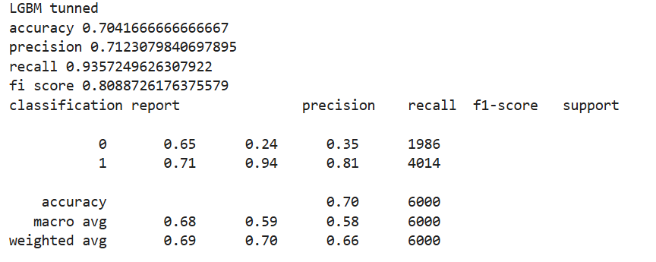

The Accuracy score is 70% and the precision value is lesser compared to recall value which tells the model predicts only positive values.

**Important Features of model are:** Pulse Pressure, Average Screen time, Physical Activity, BMI, Sleep duration, Heart Rate, Age, Daily Steps, Itchiness/Irritation in Eyes, Redness in Eye, Stress Level are having impact with target.

1. **Vote Classifier:**

**The model which are used for vote classifier is :**

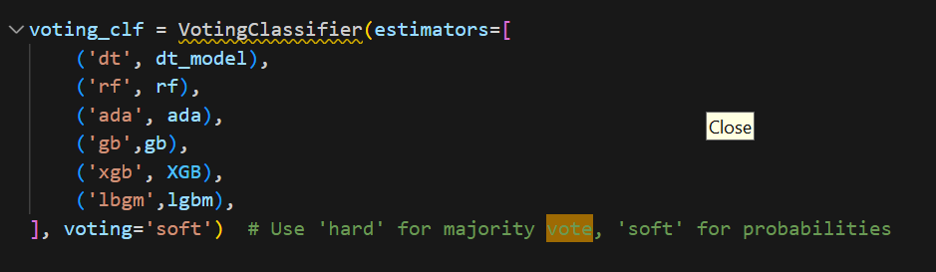

**The metrics of the model is**

**Confusion Matrix:**

**Classification Report:**

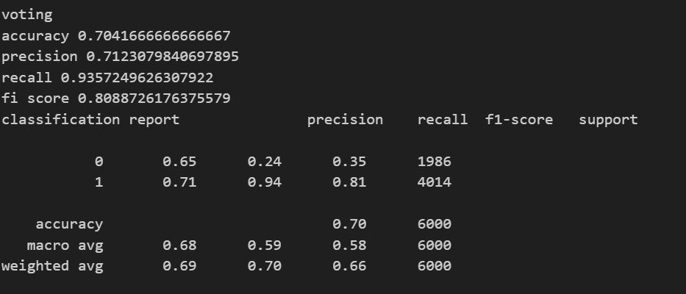

**We can observe that the model accuracy is max to 70% and the best model used from vote for predictions is LightBGM.**

Model Summary:

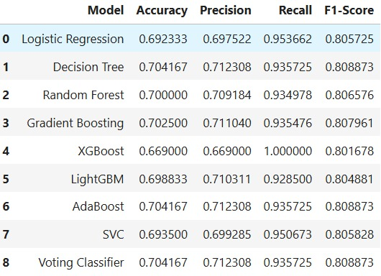

Best model is LightBGM and Gradient Boosting Model.

**Feature selection**

In the data, we have applied RFE selection for different models for choosing the best features from the data for each model.

Example:

Below are the best features of Decision Tree Model

Decision Tree - 'Gender', 'Age', 'Sleep_duration', 'Sleep_quality', 'Stress_level', 'Heart_rate', 'Daily_steps', 'Physical_activity', 'Sleep_disorder','Wake_up_during_night', 'Feel_sleepy_during_day','Caffeine_consumption', 'Alcohol_consumption', 'Smoking','Medical_issue', 'Average_screen_time', 'Blue_light_filter','Discomfort_Eye_strain', 'Redness_in_eye','Itchiness_Irritation_in_eye', 'Systolic_BP', 'Diastolic_BP','Pulse_Pressure', 'BMI', 'BP_category_Hypertension Stage 1','BP_category_Hypertension Stage 2', 'BP_category_Normal', 'Sleep_category_Long', 'Sleep_category_Short','Screen_Time_Category_Low'

Code:

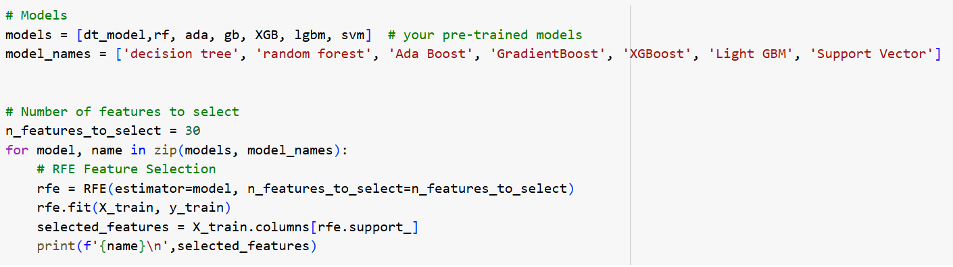

**Conclusion:**

**After applying all models LightBGM Algorithm and Gradient Boosting Model are giving good predictions results and outputs. Either of the model can be used as both give almost accuracy values and optimize threshold value in same range only.**

**Best Features for the model:**

**Comparison To Benchmark**

1. As a baseline, we considered a simple logistic regression model trained without any feature selection or parameter tuning. This model achieved an accuracy of approximately 68% on the test data.
2. The best-performing models—LightGBM and Gradient Boosting—achieved an accuracy of 70%, with better precision and recall values. These models significantly outperformed the baseline by leveraging advanced feature selection, hyperparameter tuning, and handling of class imbalance.
3. The final models clearly improved upon the benchmark in both predictive performance and reliability, especially in correctly identifying individuals with Dry Eye Disease (DED).

**Limitations**

Limitations are:

1. The dataset only includes individuals aged 18–45, limiting the model’s applicability to older adults or children who may have different risk factors for DED.  
2. Although addressed during modelling, the dataset shows mild class imbalance (65% Yes vs. 35% No for DED), which can affect generalization.  
3. No external data was added; all new features were derived from existing columns. External medical datasets or survey data could improve robustness.  
4. Some features like stress level, sleep quality, and screen time are subjective and prone to reporting bias.  
5. While addressed during modelling, multicollinearity among health features (e.g., BMI, BP) may still impact interpretability.

**Future Analysis:**  
Applying deep learning techniques, incorporating a broader demographic, and collecting data from clinical sources would enhance model performance and reliability.

Overall, the project strengthened our understanding of end-to-end machine learning workflows and their real-world impact in the health domain.